Patrick Connolly 20348060

Arvind Ganesh

1. First we wrote a program that allocates memory in the heap by using malloc to store an int and print to the screen that it has allocated an. When we run the program by itself it executes normally and the machine doesn’t complain. The memory is freed once the program finishes executing through the operating system.

When run using gdb, the program runs normally and exits normally. The memory leak is not shown using this debugger.

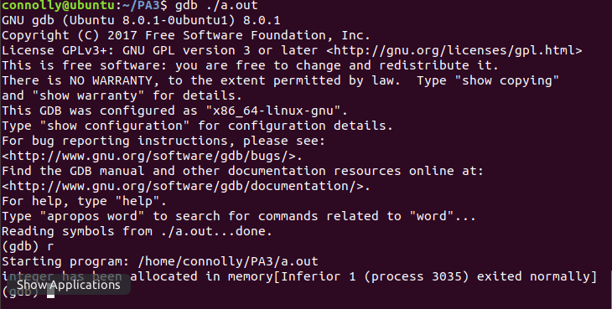

When run using Valgrind, the memory leak is able to be seen In the summary , there are 4 bytes that are definitely lost due to the unfreed integer. 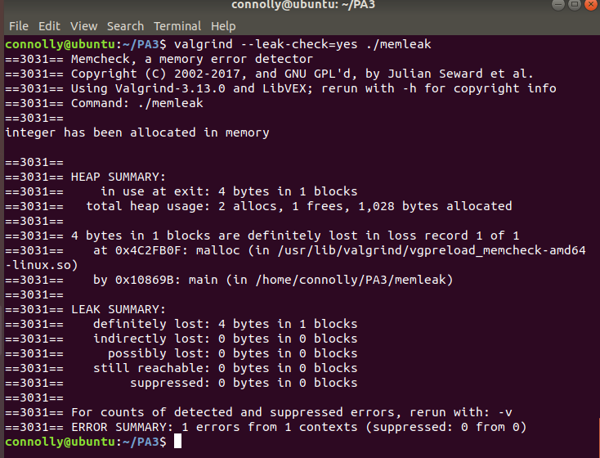

2. For part two we had to make an array of 100 integers and free them then attempt to access the array in memory. The program runs fine, with no errors. And when using Valgrind, the program runs fine and there are no errors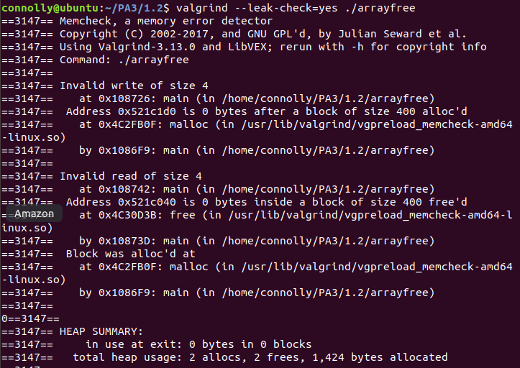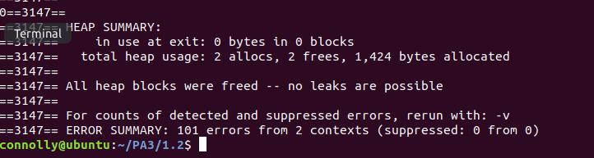

There are no errors when accessing this freed memory because it hasn’t been deleted. The OS just allows it to be overwritten in the heap